Экстендер CommercialImport
- CommercialImport Extender
  - Application
  - Features

Application

CommercialImport Extender is design for automatic import of commercials planned in Media Planner Sales software to broadcasting schedule.

Features

To perform automatic import of commercials with this extender, you need to use the Task Planner. Select: Service\Task Planner... from the main menu. The Task Planner window will now open. Create a task and add a step to it named Import commercials from Media Planner Sales.
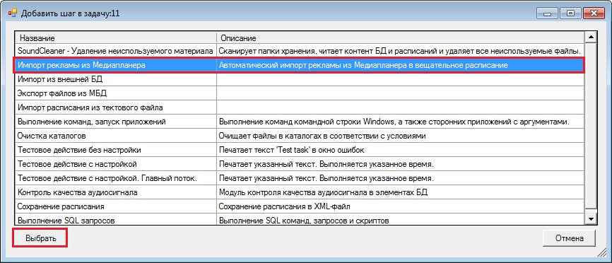
A window with step settings will appear.
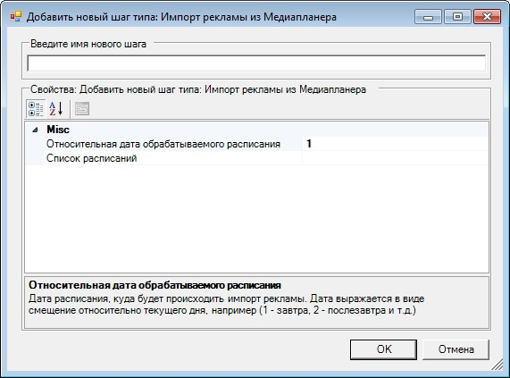
Here you must specify the following parameters:
- Relative date of processed schedule— here you must specify the date of the schedule the commercials will be imported to. The date is expressed in the form of a shift in relation to current date: 1 — tomorrow, 2 — the day after tomorrow and so on.
- Список расписаний — Specify schedules the commercials will be imported to. The Select schedules window will appear where you must mark all needed schedules and click OK.
