SQLAction Extender

Application
The extender performs SQL queries or scripts.

Configuration
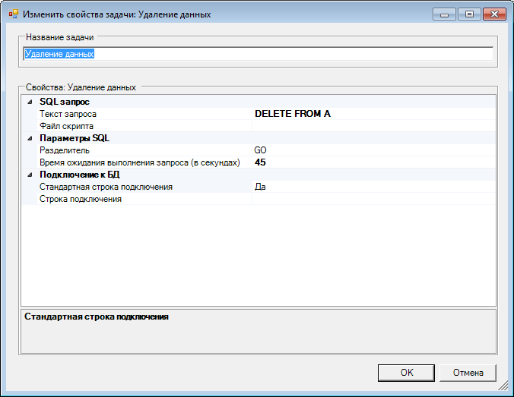
Task name – user name of the task.
1. SQL query
This group of parameters specifies execution of either specified query or a selected file of the script. If both parameters are specified, only the query will be executed.
2. SQL parameters
Divider – specifies a set of symbols that serve as a divider between queries in the script file. Default value is GO. The script file must contain line break symbols after each divider.
Query wait time Время ожидания выполнения запроса – the period (in seconds) after which, if the query has not been executed yet, a respective exception will be displayed and an error entry will be created. In case of scripts, this time period is applicable to each separate query not to all queries of the script as a whole.
3. Connection to DB
In this group, you can specify whether or not standard line of connection to DB will be used. Alternatively, you can specify it.

