SoundCleaner Extender
- SoundCleaner Extender
  - Application
  - Features
    - Creating lists of used and unused files
    - Deleting unused material manually by the user
    - Deleting unused material automatically

Application

SoundCleaner is a system built-in Digispot II extender that lets you automatically delete unused material. During operation of any version of Digispot software files are constantly added to file storage directories, which may with time lead to overload of servers when searching through files in these directories and overuse of disk space. Part of these files become irrelevant and can be deleted by the user, or automatically with the help of Task Planner.

Features

Important note: it is recommended to delete unused files at least on a monthly basis to avoid an increase in server load and reduction of system speed.

Creating lists of used and unused files
SoundCleaner extender scans all schedule blocks, skeletons as well as folder and MDB contents, creating a complete list of files used by the system. After that it scans all file storages with subdirectories, specified on Audio storage and DB storage tabs of the Global settings window and creates a list of unused files that can be deleted. You can configure parameters of schedule scanning, file search and lists creation in the Delete unused material subsection of the Basic settings section on the Other tab of Global settings window.
Important note: the list of unused files does not include files created during the last hour to avoid deleting files copied or recorded in course of the operation.
Note: starting from version 2.15.102 there is a possibility to recognize different symbolic names of the same file storage.

Deleting unused material manually by the user
To delete unused files manually, select Service\Delete unused material… from the main menu. The Delete unused audio window will now open.
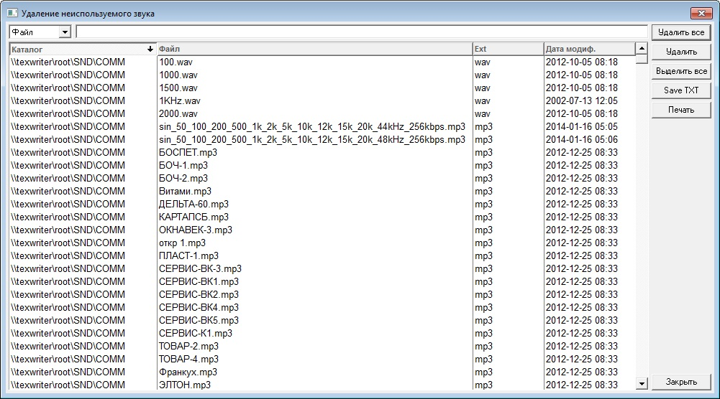
Here you can see a list of files unused by the system and that can be deleted. The list contains the following columns:
- Directory — address of file storage directory.
- File — file name.
- Ext — file extension.
- Modification date — date of last modification.
There is a filter above that helps to find the needed files:
- Ext — search files by extension.
- Directory — search files by storage directory name.
- File — search files by name.
On the right there are several buttons:
- Delete all — delete all listed files.
- Delete — delete selected files from the list.
- Select all — select all listed files.
- Save TXT — save the list of unused files to text file.
- Print — print list.

Deleting unused material automatically
Automatic deletion of unused files is performed with the help of the Task Planner. To run it, select: Service\Task Planner... from the main menu. Create a task and add a step to it named SoundCleaner — delete unused material.
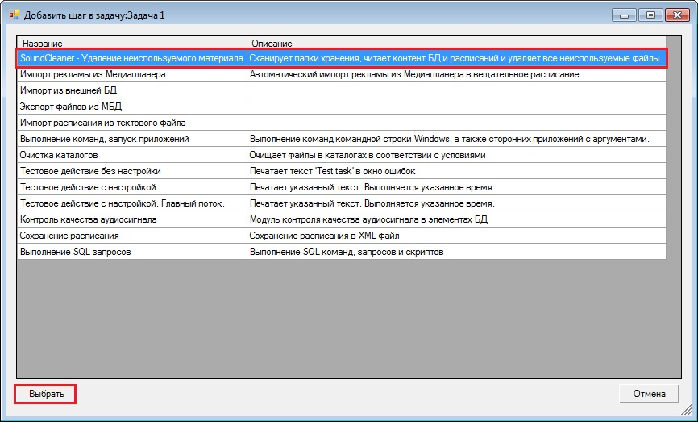
A window with step settings will appear.
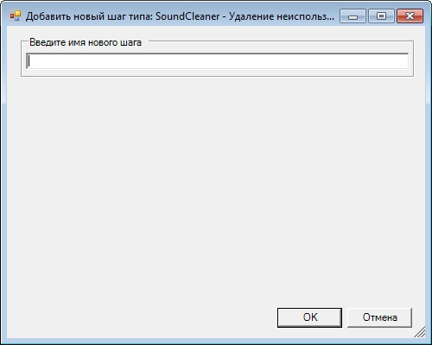
Here you must enter any user name for the step. Then specify run type (Configuring automatic run of task). Now unused files will be deleted automatically according to specified schedule (initiator).
Note: automatic deletion of unused files with the help of the Task Planner can be switched off in the Component control window. If you do this, no step named SoundCleaner — delete unused material will be displayed in the Add step to task window of the Task Planner.

