MagGenerate Extender
- MagGenerate Extender
  - Application
  - Features

Application

MagGenerate is a system built-in extender that lets you automatically generate schedule in DIGISPOT II MAG software with the help of the Task Planner.

Features

To automatically generate a schedule with this extender, you have to use the Task Planner. Select the following main menu item: Service\Task Planner…. The Task Planner window will appear. Create a task and add a step to it, named MagGenerate — Generate schedule (MAG).
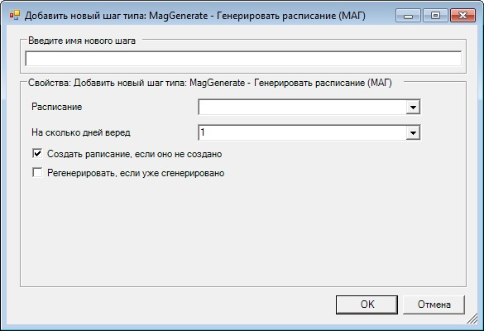
Here, specify the name of the step and its properties:
- Schedule — select schedule that you need to generate.
- How many days — select the number of days you wish to generate schedule for (starting from tomorrow).
- Create schedule if not available — checking the box allows forming schedule blocks according to an available grid, if it has not been done yet. The box is checked by default.
- Regenerate, if generated already — check the box to undo changes made during previous generation.

