ImagePane Extender
- ImagePane Extender
  - Application
  - Features
    - Loading files and images
    - Viewing images
    - Linking images to database items

Application

ImagePane Extender lets you load images to MDB categories, view them and link images to database items. When forming information about X-Player state or during export of schedule to xml file, it will have the information about linked images written into it.

Features

Loading files and images
You can add images to any MDB category by loading the needed files with the help of File Browser.
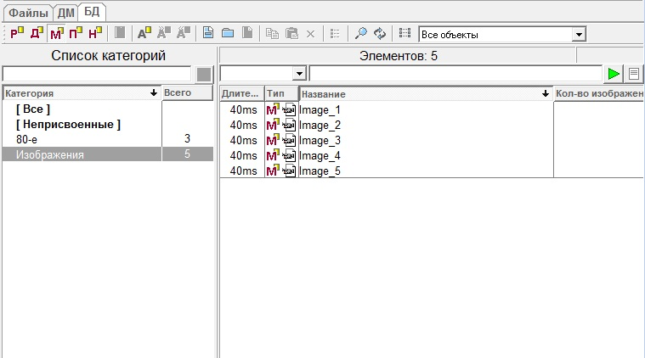
It is also possible to add images by opening the Object properties window. Here, on the Images tab, press Add file..., select needed files and specify MDB category where you wish to place files to.
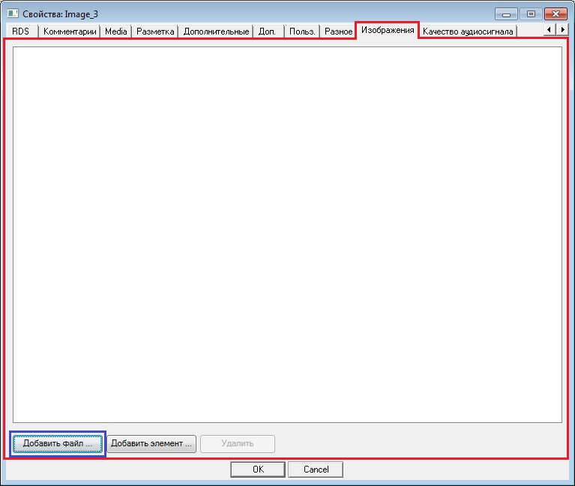

Viewing images
To view an image, select it and hit space, or, alternatively, select Listen from the context menu. A window with image will then appear.
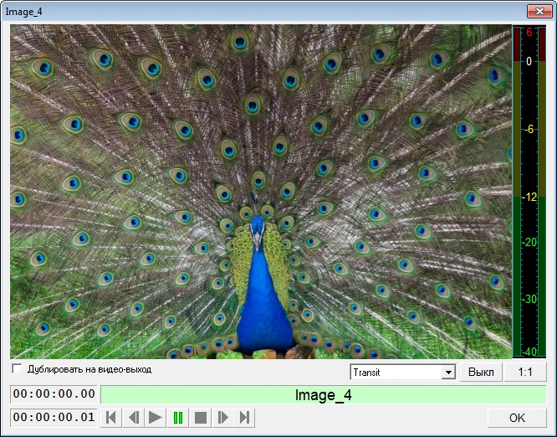

Linking images to database items
You can only link images to those items that are MBD objects, which means that their DB ID is not equal to zero (General tab of the Object properties window). For this, select the needed item and choose Object properties from the context menu. In the next window, go to the Images tab. Then click on Add item….
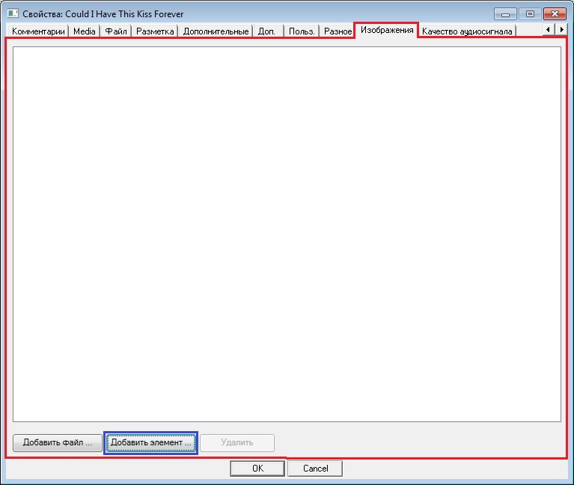
The window Select DB item will now appear. Here you have to choose the needed files and click OK.
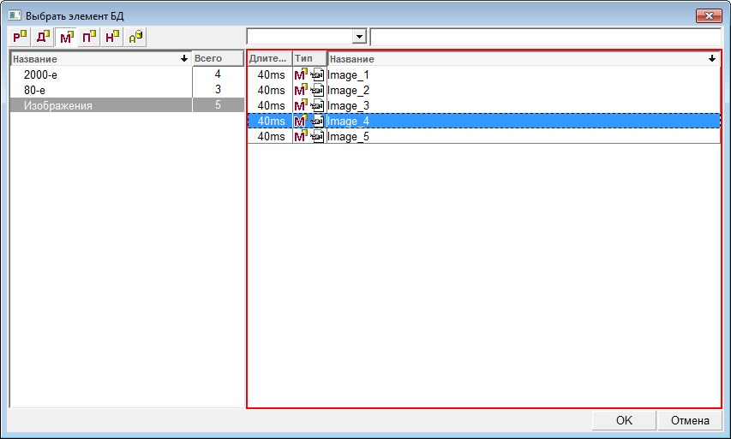
Now all images linked to this item will be displayed on the Images tab.
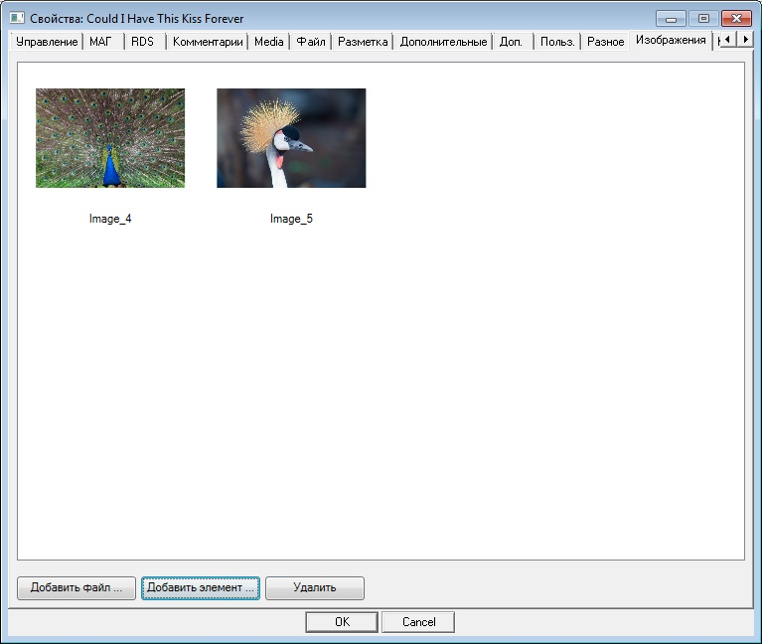
If needed, you can delete an image linked to the object by selecting the image and clicking on Delete.
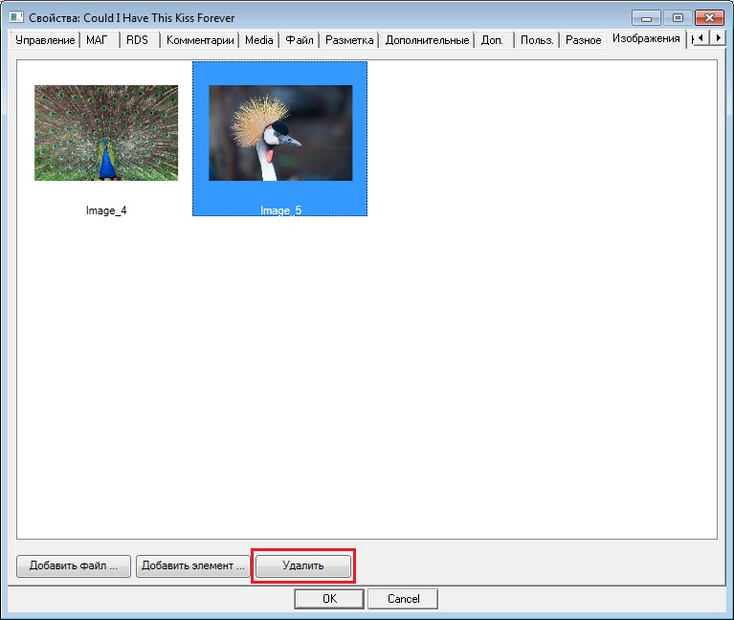
This will only remove the image from the object’s properties, not from the database.
You can configure the list of displayed fields of the DB tabs in such a way that you will be able to see the number of linked files and paths to them. To do this, right-click on field names and the List settings window will appear. Then make two columns visible: Number of images and Linked images. Click OK. Now all information about linked images will be displayed in the list of database objects.
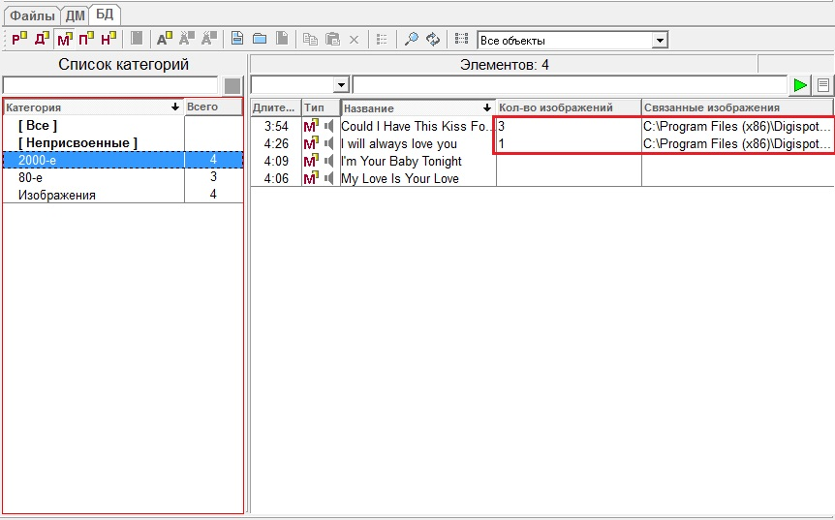
Note. Information from “Number of images” and “Linked images” columns is exported when saving the schedule as XMl file, forming information about X-Player’s state and schedule editing log..

