FolderCleaner Extender
- FolderCleaner Extender
  - Application
  - Features

Application

The extender performs deletion of files and subdirectories obsolete by date and time of creation / modification or upon reaching the total allowable memory use. The search and checking of files is performed within specified root directories and their subdirectories. The files that fall under the checking condition are determined by the mask (or group of masks).

Features

To automatically delete obsolete files and subdirectories with this extender, you have to use the Task Planner. Select the following main menu item: Service\Task Planner…. The Task Planner window will appear. Create a task and add a step to it, named Directory cleaning.
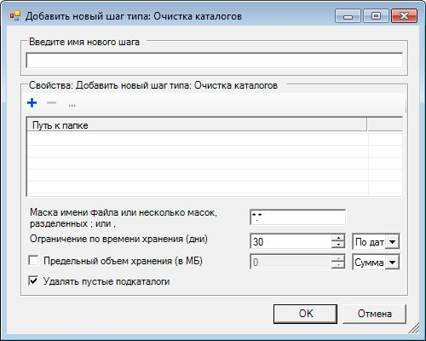
In the Enter the name of the new step field, enter any user task name.
Below, you must specify a list of root directories with files.
File name mask – specifies one or several (divided by ; or ,) file name masks. Only files corresponding to specified masks (mask) are checked and deleted.
Storage time limit (days) – maximum storage time for files (in days), максимальный срок хранения файлов (в днях), as well as determination of storage time by date of creation or modification of the file. Determines deleted files that are obsolete by date of creation or modification in relation to storage time, as well as empty subdirectories that are considered obsolete based on the same criteria.
Maximum storage size (in MB) – if this parameter is specified, the files will also be deleted if they exceed maximum storage size (in megabytes) in relation to the value specified in this parameter. The oldest files by date of creation will be deleted until their total size is less than or equal to specified value.
Delete empty subdirectories – if this parameter is checked, subdirectories that have become empty as a result of cleaning will be automatically deleted. Root directories are never deleted.
Delete only in subdirectories - if this parameter is checked, only subdirectory files will be processed. Files in root directories corresponding to specified mask will be ignored and will not be deleted.

