DecroAutomatControl.Handler.AutomaticScheduleHandler Extender

Application
This extender is designed for batch processing of several schedules by the Decrochage Machine.

Features
To process schedules with this extender, you have to use the Task Planner. Select the following main menu item: Service\Task Planner…. The Task Planner window will appear. Create a task and add a step to it, named Batch processing of schedules.
A window with settings will appear:
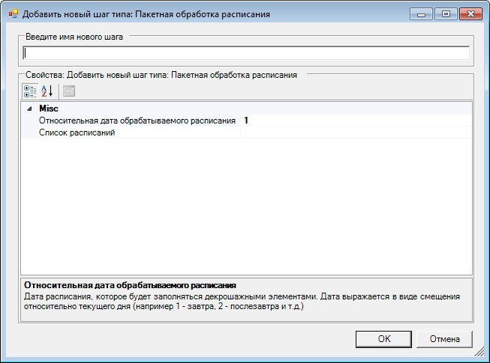
Insert any user name of the step here. Specify date, for which the schedules will be processed by using a shift in relation to current day. For example 1 means process schedules for tomorrow, 2 — the day after tomorrow and so on.
You will also have to select schedules that will be processed. To do this, click in the List of schedules line. The Select schedules window will now appear.

Check the boxes next to schedules you need to process. Then click OK.
Please note: To process schedules, the extender uses rules specified in Decrochage Machine. Each schedule may have its own set of rules specified for it.

