- Clock Machine configuration samples overview
Every Clock machine contains a full sample set. To select the required configuration just copy this sample over cdsconfig configuration file or use specially designed command “setcl N” and restart the machine. However each netconfig configuration MUST be changed according current IP addresses in the local net.
Caps-Clock Server contains one special D3 configuration file for GPI signals. Just copy it over signalmapconfig configuration file and restart server to use СС Server with D3 Caps-Clock configuration.
This sample set is free of charge and can be edited to get required configuration. Change rules are described in appropriate manuals. Or it can be done by our programmers by a special request.

- Sample 1 “Simple Clock”
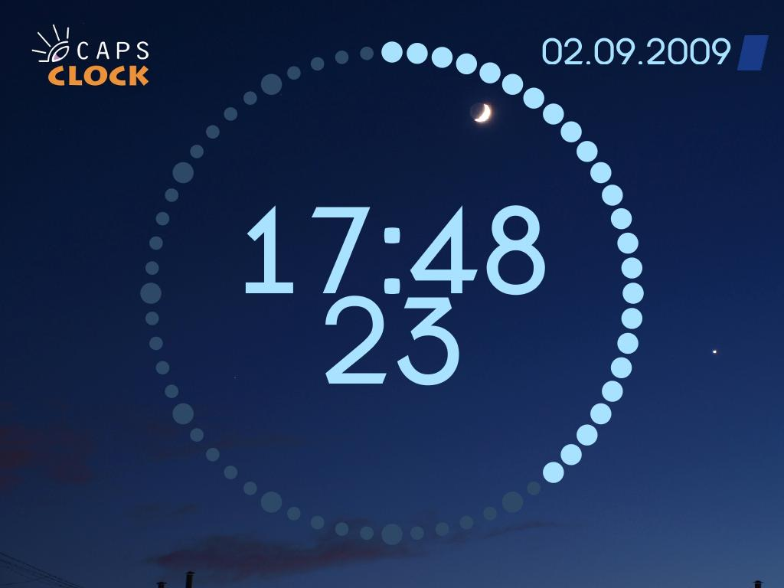
This configuration can be used in 3 modes:
- Stand-alone mode
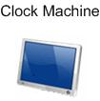
In this mode Clock-Machine is not connected to the net and works using internal timer. Clock type is defined in local configuration file.
- Stand-alone mode with NTP server
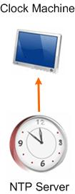
In this mode Clock-Machine is connected to NTP server through the local net and receives SYNC time signals. Clock type is defined in local configuration file.

- Collaborative mode
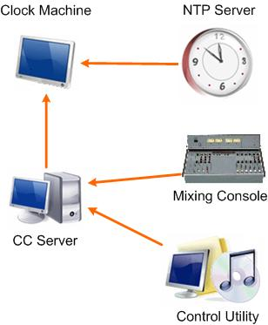
In this mode Clock-Machine is connected to NTP server through the local net and receives SYNC time signals. Clock type is defined in local configuration file, but it can be changed by a command from the Caps-Clock Server. CC Server sends this command when receives GPI1 signal from mixing console.
Control Utility can be connected to CC Server and allows changing of:
- Clock type
- Clock thresholds
- Cycle
- Clock displacement

- Sample 2 “Clock and 3 indicators”
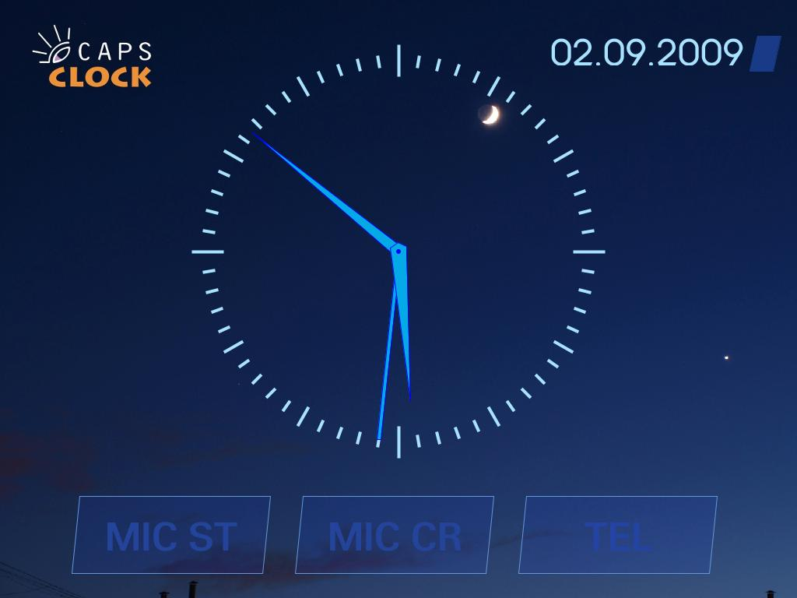
This configuration will work with full fuctionality in Collaborative mode only.
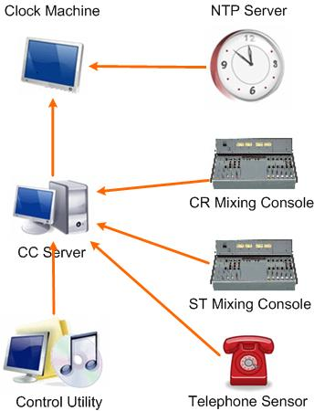
In this mode Clock-Machine is connected to NTP server through the local net and receives SYNC time signals. Clock type is defined in local configuration file, but it can be changed by a command from the Caps-Clock Server. CC Server sends this command when receives GPI1 signal from CR mixing console.
CC Server sends command to turn on/off appropriate indicator on the Clock-Machine when receives GPI2 (Microphone CR) signal from CR Mixing console, GPI3 (Microphone ST) signal from ST Mixing Console or GPI4 (Telephone ring) signal from telephone sensor.
Control Utility can be connected to CC Server and allows changing of:
- Clock type
- Clock thresholds
- Cycle
- Clock displacement

- Sample 3 “Clock with cycle and rectangular timer”
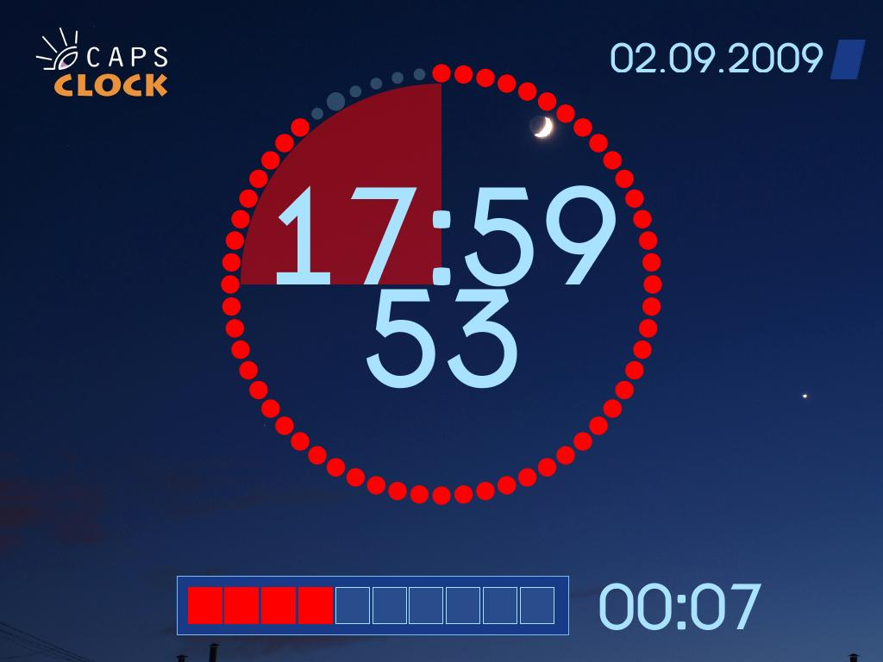
This configuration can be used in 3 modes:
- Stand-alone mode
In this mode Clock-Machine is not connected to the net and works using internal timer. Clock and timer types are defined in local configuration file.
- Stand-alone mode with NTP server
In this mode Clock-Machine is connected to NTP server through the local net and receives SYNC time signals. Clock and timer types are defined in local configuration file.

- Collaborative mode
In this mode Clock-Machine is connected to NTP server through the local net and receives SYNC time signals. Clock and timer types are defined in local configuration file, but clock type can be changed by a command from the Caps-Clock Server. CC Server sends this command when receives GPI1 signal from mixing console.
Control Utility can be connected to CC Server and allows link/unlink timer and clock, fulfill operative timer control and change:
- Clock type
- Clock thresholds
- Clock cycle
- Clock displacement
- Timer type
- Timer thresholds
- Timer cycle
- Timer start time
- Sample 4 “Clock with cycle, round timer and 3 indicators”
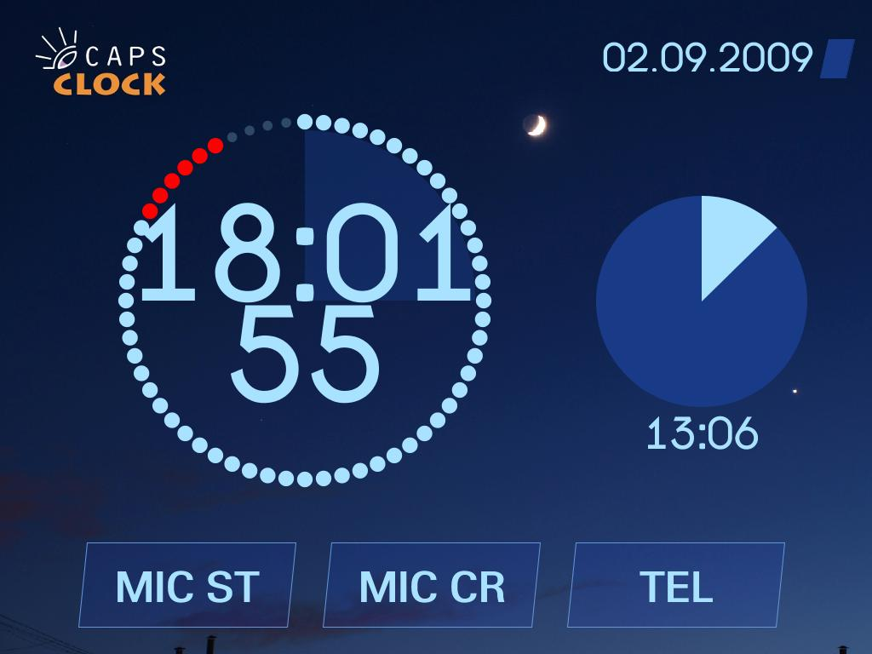
This configuration will work with full fuctionality in Collaborative mode only.
In this mode Clock-Machine is connected to NTP server through the local net and receives SYNC time signals. Clock and timer types are defined in local configuration file, but clock type can be changed by a command from the Caps-Clock Server. CC Server sends this command when receives GPI1 signal from CR mixing console.
CC Server sends command to turn on/off appropriate indicator on the Clock-Machine when receives GPI2 (Microphone CR) signal from CR Mixing console, GPI3 (Microphone ST) signal from ST Mixing Console or GPI4 (Telephone ring) signal from telephone sensor.

Control Utility can be connected to CC Server and allows to link/unlink timer and clock, to fulfill operative timer control and to change:
- Clock type
- Clock thresholds
- Clock cycle
- Clock displacement
- Timer type
- Timer thresholds
- Timer cycle
- Timer start time
- Sample 5 “Clock with microphone indicator”
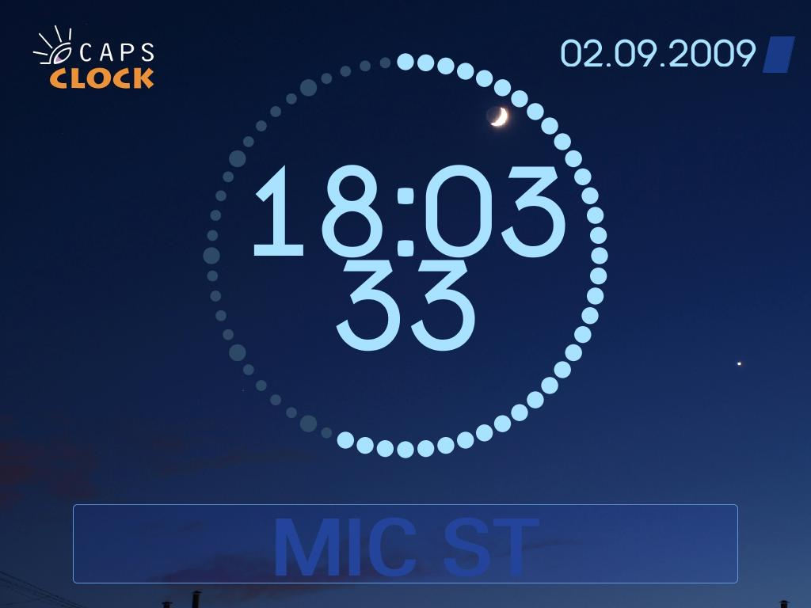
This configuration will work with full fuctionality in Collaborative mode only.
In this mode Clock-Machine is connected to NTP server through the local net and receives SYNC time signals. Clock type is defined in local configuration file, but it can be changed by a command from the Caps-Clock Server. CC Server sends this command when receives GPI1 signal from mixing console.
CC Server sends command to turn on/off microphone indicator on the Clock-Machine when receives GPI3 (Microphone ST) signal from Mixing Console.
Control Utility can be connected to CC Server and allows changing of:
- Clock type
- Clock thresholds
- Clock cycle
- Clock displacement

- Sample 6 “3 Zone Clocks with creeping line”
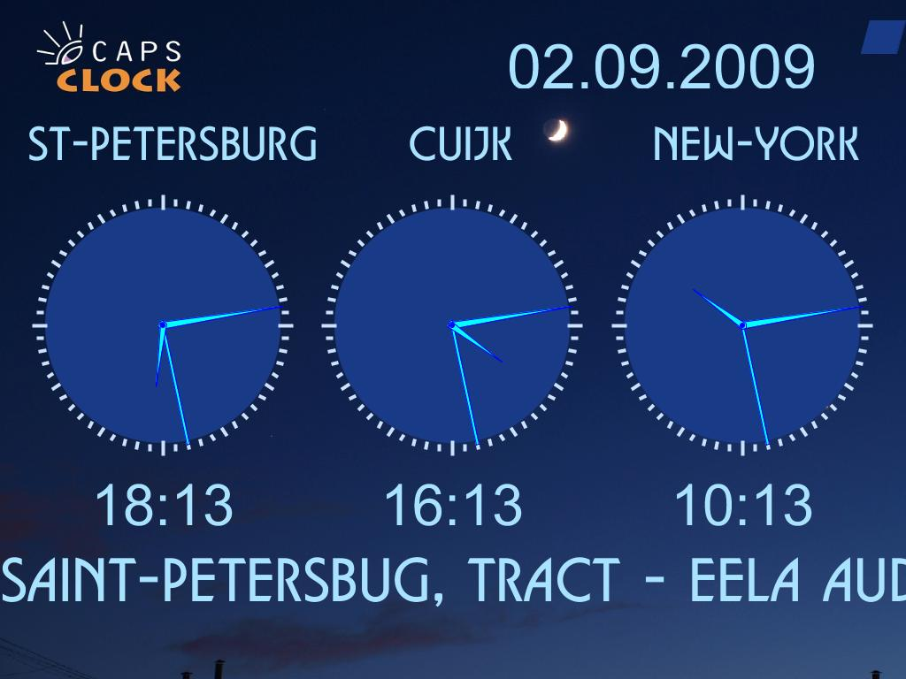
This configuration will work with full fuctionality in Collaborative mode with connected Control Utility only.
In this mode Clock-Machine is connected to NTP server through the local net and receives SYNC time signals.
Control Utility is connected to CC Server and allows changing of:
- Every Clock type
- Every Clock thresholds
- Every Clock cycle
- Every Clock displacement
- Label name for every Clock

It allows changing of text in the creeping line and to control its font size, scroll speed and scroll mode.
- Sample 7 “Clock with DJ indication scheme”
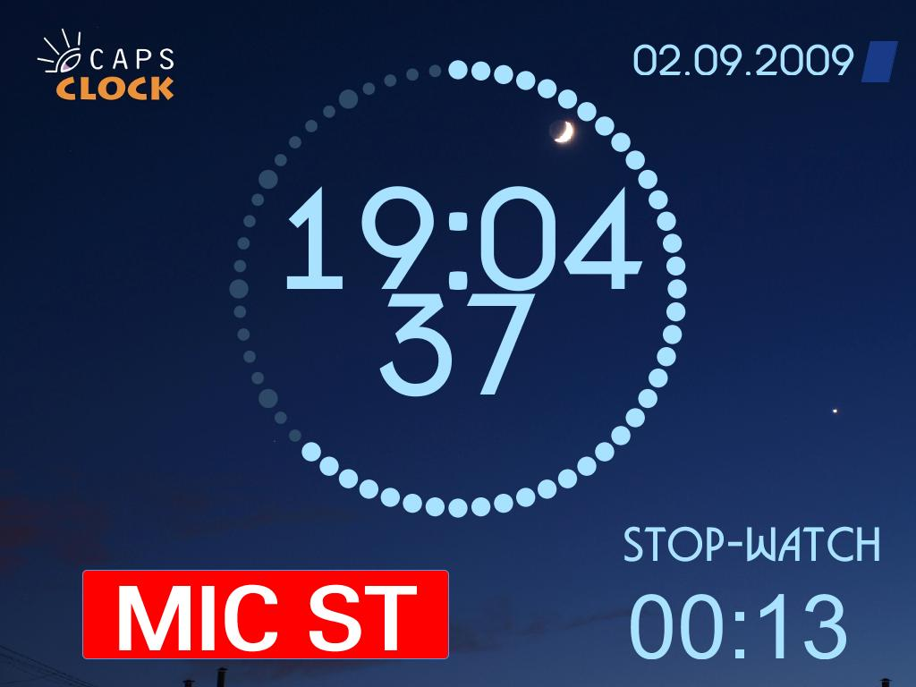
This configuration will work with full fuctionality in Collaborative mode only.
In this mode Clock-Machine is connected to NTP server through the local net and receives SYNC time signals. Clock type is defined in local configuration file, but it can be changed by a command from the Caps-Clock Server. CC Server sends this command when receives GPI1 signal from mixing console.
CC Server sends command to turn on/off microphone indicator and to start/stop stop-watch on the Clock-Machine when receives GPI3 (Microphone ST) signal from Mixing Console.
Control Utility can be connected to CC Server and allows changing of:
- Clock type
- Clock thresholds
- Clock cycle
- Clock displacement
- Timer start time
It allows fulfilling operative control of stop-watch as well.
- Sample 8 “3 Zone Clocks with news”
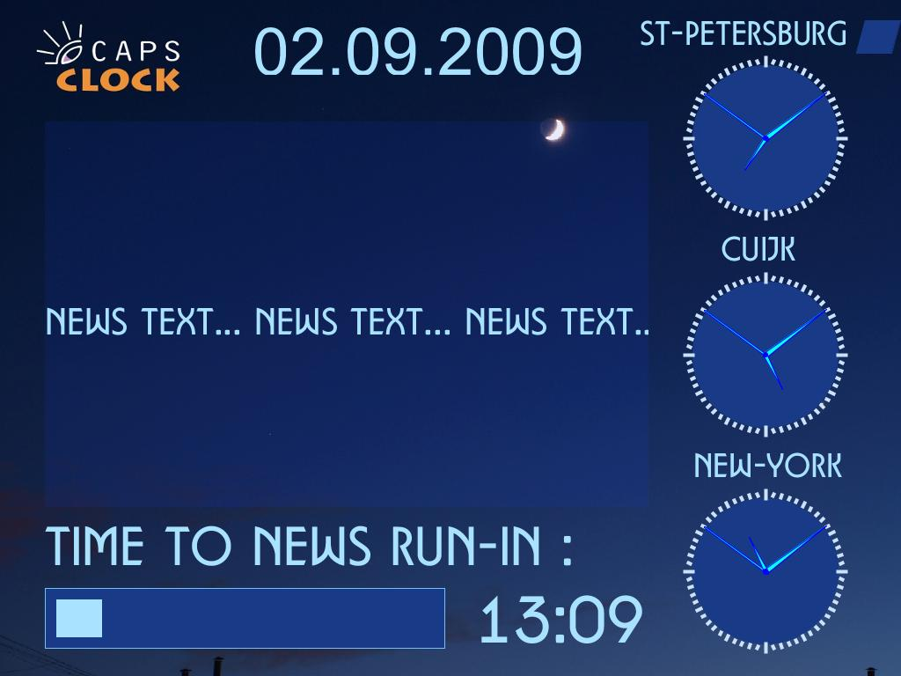
This configuration will work with full fuctionality in Collaborative mode with connected Control Utility only.
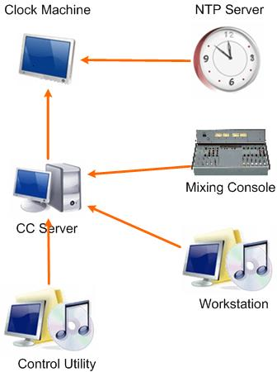
In this mode Clock-Machine is connected to NTP server through the local net and receives SYNC time signals.
Control Utility is connected to CC Server and allows changing of:
- Every Clock type
- Every Clock thresholds
- Every Clock cycle
- Every Clock displacement
- Label name for every Clock
- Timer start time
- Timer length
- News window text (from file as well)
- Scroll window mode
- Scroll window speed
- Scroll window font size
CC Server sends command to change clock type on the Clock-Machine when receives GPI1 (Clock type exchange) signal and displays the next page of news in the news window when receives GPI5 (Next page) signal from Mixing console.
Any connected workstation can send ENM (Enhanced Network Message) “News Text” to CC Server to force it load of new text to the news window.
- Sample 9 “Clock with weather indicators”
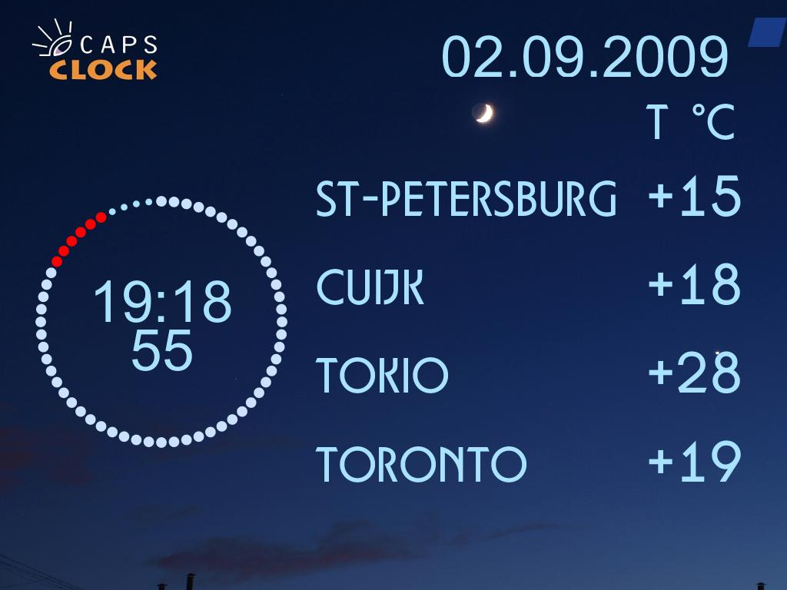
This configuration will work with full fuctionality in Collaborative mode with connected Control Utility only.
In this mode Clock-Machine is connected to NTP server through the local net and receives SYNC time signals. Clock type is defined in local configuration file, but it can be changed by a command from the Caps-Clock Server. CC Server sends this command when receives GPI1 signal from mixing console
Control Utility is connected to CC Server and allows changing of:
- Clock type
- Clock thresholds
- Clock cycle
- Clock displacement
- Every label name
- Every label font size
- Every temperature value
- Every temperature font size
- Sample 10 “D3 configuration”
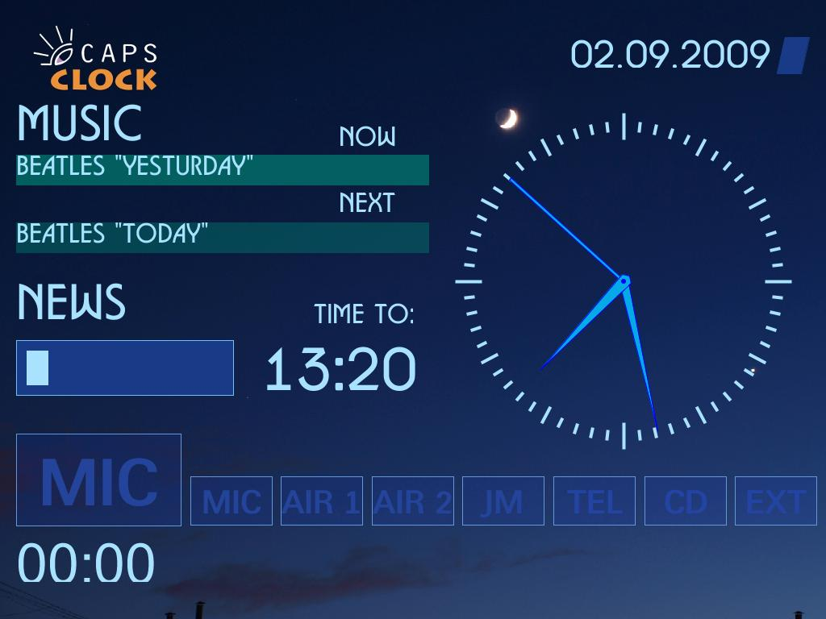
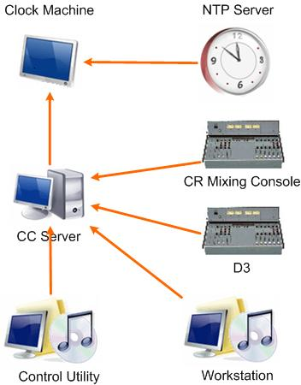
This configuration will work with full fuctionality in Collaborative mode with connected Control Utility.
In this mode Clock-Machine is connected to NTP server through the local net and receives SYNC time signals.
CC Server sends command to turn on/off appropriate indicators on the Clock-Machine when receives GPI1 (Microphone ST & Stop-Watch) and GPI2 (Telephone Ring) signals from ST Mixing console and GPI3 (Microphone CR), GPI4 (Air1), GPI5 (Air2), GPI6 (Jingle Machine), GPI7 (CD Player) and GPI8 (External Line) signals from D3.
Control Utility is connected to CC Server and allows changing of:
- Clock type
- Clock thresholds
- Clock cycle
- Clock displacement
- Timer start time
- Timer length
- Stop-Watch parameters and operative control
- Current playlist item name and parameters
- Next playlist item name and parameters
Any connected workstation can send ENM (Enhanced Network Message) “New Item”, “Next item” and “Time to” to CC Server to force it load of new playlist item name, next playlist item name and timer length to news start instead of Control Utility.
- Sample 11 “Local Clock with 4 Zone Clocks”

This configuration can be used in 3 modes:
- Stand-alone mode
In this mode Clock-Machine is not connected to the net and works using internal timer. All clock types and displayments are defined in local configuration file.
- Stand-alone mode with NTP server
In this mode Clock-Machine is connected to NTP server through the local net and receives SYNC time signals. All clock types and displayments are defined in local configuration file.

- Collaborative mode
In this mode Clock-Machine is connected to NTP server through the local net and receives SYNC time signals. All clock types and displayments are defined in local configuration file, but local clock type can be changed by a command from the Caps-Clock Server. CC Server sends this command when receives GPI1 signal from mixing console.
Control Utility can be connected to CC Server and allows changing of:
- Every Clock type
- Every Clock thresholds
- Every Clock Cycle
- Every Clock displacement
- Every Label name
- Sample 12 “Clock with channel indicators”
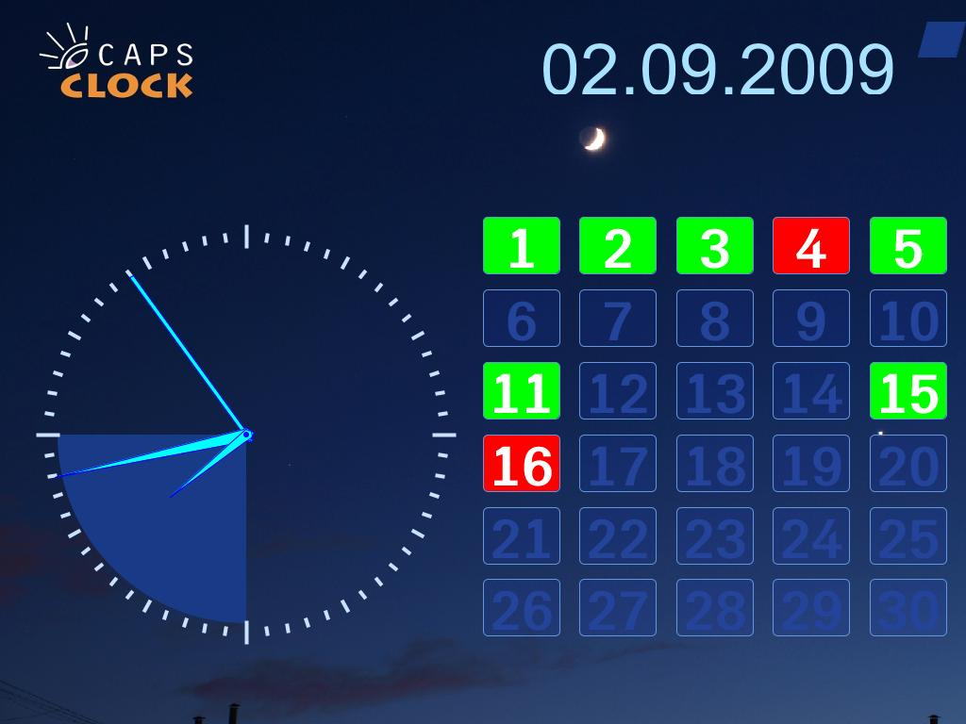
This configuration will work with full fuctionality in Collaborative mode only.
In this mode Clock-Machine is connected to NTP server through the local net and receives SYNC time signals. Clock type is defined in local configuration file, but it can be changed by a command from the Caps-Clock Server. CC Server sends this command when receives GPI1 signal from mixing console.
If Control Utility is connected to CC Server it allows changing of:
- Clock type
- Clock thresholds
- Cycle
- Clock displacement
Any connected workstation can send ENM (Enhanced Network Message) “Channel ON”, “Channel OFF” and “Channel ERROR” to CC Server to force it display of the appropriate indicator.

- Sample 13 “Simple Clock with information”
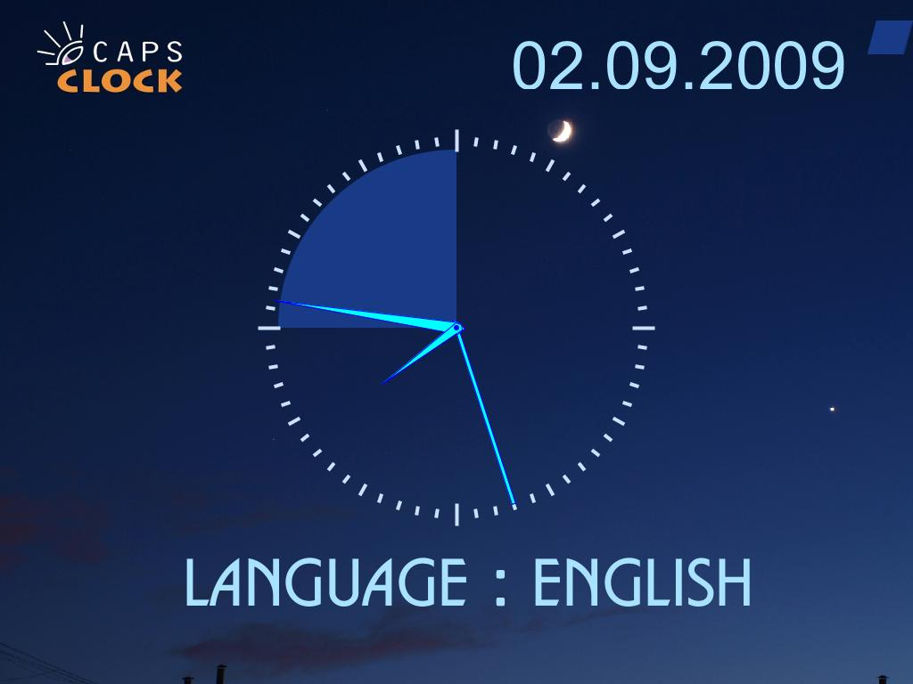
This configuration will work with full fuctionality in Collaborative mode with connected Control Utility only.
In this mode Clock-Machine is connected to NTP server through the local net and receives SYNC time signals. Clock type is defined in local configuration file, but it can be changed by a command from the Caps-Clock Server. CC Server sends this command when receives GPI1 signal from CR mixing console.
Control Utility is connected to CC Server and allows changing of:
- Clock type
- Clock thresholds
- Clock cycle
- Clock displacement
- Information text
- Information text size
- Information scroll mode
- Information scroll speed

